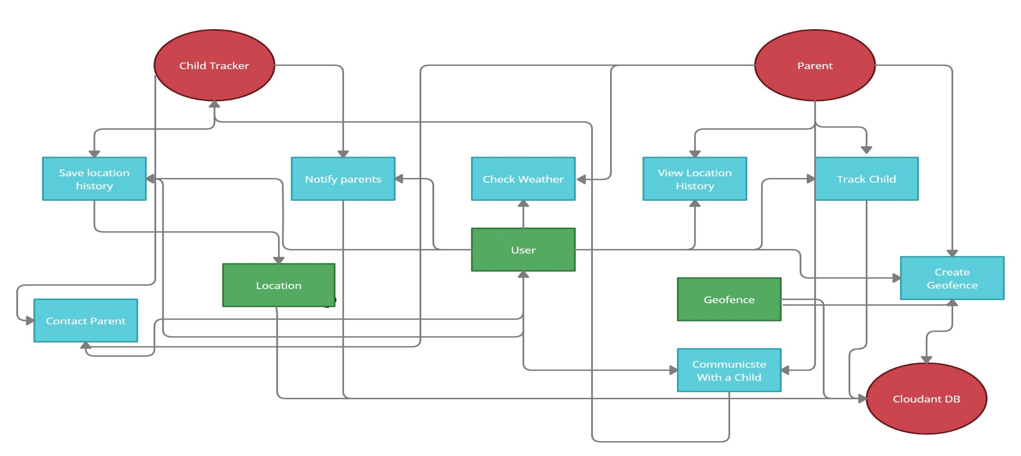 **Data Flow Diagram**

Data Flow Diagram

|  |  |
| --- | --- |
| Date | 26 October 2022 |
| Team ID | PNT2022TMID02431 |
| Project Name | Iot based safety gadget for child safety monitoring and notification |
| Maximum Marks | 4 Marks |

child tracker

parent

Cloud database